Men's Health Week 2023:
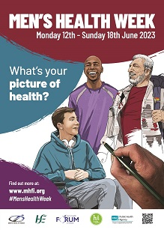

Online Promotion of Events

Men's Health Week (MHW) will run from Monday 12th until Sunday 18th June this year. The theme for MHW 2023 is ‘THE PICTURE OF HEALTH’, and everyone is urged to think about WHAT DOES THAT LOOK LIKE TO YOU?

This focus lends itself to a wide range of ways to mark this occasion. However, you don’t have to stick rigidly to this particular topic. Anything which promotes the week and encourages men and boys to lead healthier lifestyles, to be more aware of preventable health problems, to seek early detection and treatment for health difficulties, and to access help and support will be very welcome!

The Men's Health Forum in Ireland (MHFI) has created a web page for MHW 2023 at: https://www.mhfi.org/mhw/mhw-2023.html We will also be promoting the details of any activities that will be held throughout Ireland. This will help everyone to find out what is happening during the week, and to get details on how to join in. We hope that this information will give some profile and recognition to all those groups across the island that are doing something for and with men.

Your activity might be health checks, or a conference, or a launch, or a game, or a seminar, or a competition, or a workshop, or a lunch, or a training course, or a drama, or a display, or a health fair ... Whatever it is you are doing, if you would like to have the details promoted by us, please save this file to your computer, complete (using a word processor) as much of the form below as is appropriate to you, and return it to us by email attachment as soon as possible. Alternatively, you may prefer to submit your details using our online form which can be found at: www.mhfi.org/mhw/promote-an-event.html

Name of Activity:

Date:

Start / Finish Time:

Venue / Location:

Name of Organisation Running Event / Activity:

Brief Description of the Activity - Maximum 150 Words [What it will involve, who it is for etc.] ...

Is there an Entry Fee?:

Contact Person:

Telephone Number:

Email Address:

Website Address:

