Men's Health Week 2020:
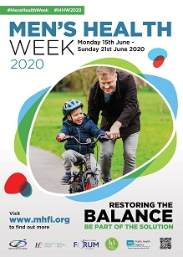
Online Promotion of Events

Men's Health Week (MHW) will run from Monday 15th until Sunday 21st June this year. The theme for MHW 2020 is RESTORING THE BALANCE, and everyone is being asked to BE PART OF THE SOLUTION and to improve their own health and the health of males around them.

This focus lends itself to a wide range of ways to mark this occasion. However, you don’t have to stick rigidly to this particular topic. Anything which promotes the week and encourages men and boys to lead healthier lifestyles, to be more aware of preventable health problems, to seek early detection and treatment for health difficulties, and to access help and support will be very welcome!

The Men's Health Forum in Ireland (MHFI) has created a special section on one of its web pages (https://www.mhfi.org/mhw/mhw-2020.html) to promote the details of any activities or happenings that will be held throughout Ireland. This will help everyone to find out what is happening during the week, and to get details on how to join in. We also hope that this information will give some profile and recognition to all those groups across Ireland that are doing something for and with men.

COVID-19 has meant that many traditional MHW face-to-face events (e.g. health checks, conferences, launches, games, seminars, competitions, workshops, lunches, training courses, performances, displays, health fairs ...) cannot take place this year. However, many groups across Ireland are being creative and innovative about how they can engage with / support men. Whatever it is you are doing, if you would like to have the details included on our website, please save this file to your computer, complete (using a word processor) as much of the form below as is appropriate to you, and return it to us by email attachment as soon as possible. Alternatively, you may prefer to submit your details using our online form which can be found at: www.mhfi.org/mhw/promote-an-event.html


Name of Activity:

Date:

Start / Finish Time:

Venue / Location:

Name of Organisation Running Event / Activity:

Brief Description of the Activity - Maximum 150 Words [What it will involve, who it is for etc.] ...

Is there an Entry Fee?:

Contact Person:

Telephone Number:

Email Address:

Website Address:

