 | Men’s Health Week 2011  Poster Caption Competition | 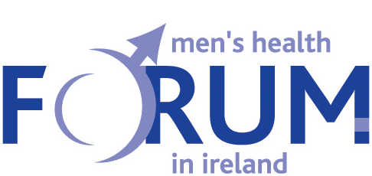

Men’s Health Week (MHW) always begins on the Monday before Father's Day and ends on Father's Day itself. This year, it will run from Monday 13th until Sunday 19th June 2011.

The Men’s Health Forum in Ireland (MHFI) and the Irish Cancer Society (ICS) are inviting you to mark this occasion by taking part in an Ireland-wide poster caption competition. The aim of this competition is to find out what males are thinking about at this time - especially in relation to their own health and well-being.

On the next page, you will find a special version of the MHW 2011 poster. This version has ‘thought bubbles’ coming from the heads of the two main characters. We want you to come up with an idea for what each of these men might be thinking about - in these ‘challenging times’.

It’s all quite simple ...

- You must be male and aged 16 years or over to enter.
- Captions can be funny, sad, factual, serious ... but must relate to what men are thinking about in relation to their health, well-being and life situation.
- Type your ideas into the ‘thought bubbles’ on the poster - when you click in the box, you will see a square ‘text box’ to type within. All captions must fit within the text box.
- The maximum number of words in each ‘thought bubble’ is 35.
- The default text size is set at Arial 12. You may increase the text size, but must not decrease it.
- Any material deemed to be offensive will not be considered further.
- Fill in your contact details in the entry form below.
- Save this file, and email a copy of it as an attachment to: posters@mhfi.org
- Send us your suggestions by no later than 5.00pm on Friday 1st July 2011.
- You will receive an email to acknowledge that we have received your entry.

A panel of judges will review all the entries, and will select three which, they feel, best represents men’s lives / issues / concerns ... in Ireland today. They will announce their decision in late July 2011. These three people will each receive a pair of tickets for the launch of the ‘Movember’ celebrations in Autumn 2011 (which will include travel expenses and overnight accommodation in Dublin). The judges’ decision is final! All entrants will receive an electronic certificate (which they can print if they wish) to acknowledge their participation in this competition.

However, before you submit an entry, please note that ...

- The winners will be invited to a photo-shoot, and it is anticipated that a Press Release will be issued on this matter.
- The captions that you send will not be subject to copyright, and may be used by ICS or MHFI in the future.
- All of the posters entered will be made available online. However, only your name will appear on your poster - not any other contact details.
- The information that you give us will only be used to send out acknowledgement emails and certificates. It will not be given to any third party, or used for mailouts that you have not asked to be part of.
- Your contact details will be destroyed no later than six months after the competition has ended - unless you have asked to be on the ICS or MHFI mailing lists.

Now, please complete the entry form ...

I have read all of the information above, and agree with the terms and conditions of entry. My contact details are:

Name:

Address:

Telephone Number:

Email Address:

Please tick if you would like to receive further mailings from ICS and/or MHFI

If you have any questions about this competition, please contact Colin Fowler from the Men’s Health Forum in Ireland at
Email: colin@mhfi.org / Telephone: 0044 771 5164796.

Good Luck!

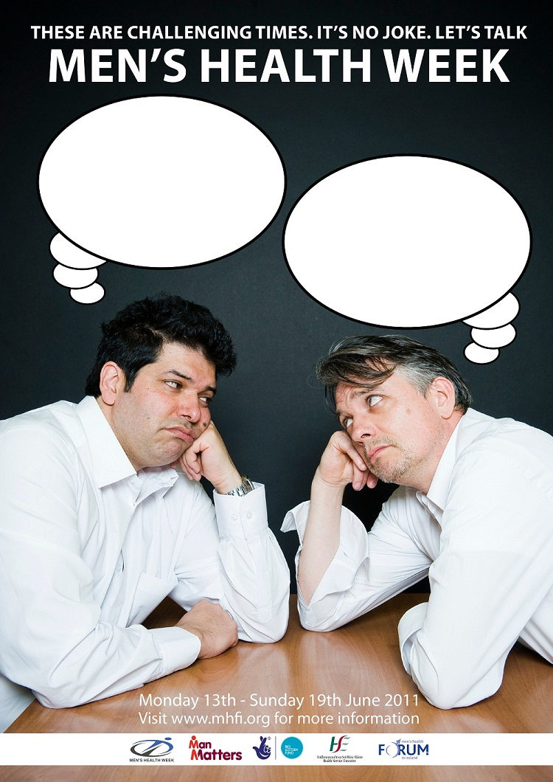

This project has been organised by the Men’s Health Forum in Ireland supported by the Irish Cancer Society

