The Men’s Health Forum in Ireland
12 Week Fitness Training Programme



Week 3: Monday 28th June - Sunday 4th July 2010

Welcome to Week 3 of the Men’s Health Forum in Ireland 12 Week Fitness Training programme. Hopefully, you have done your ‘homework’ from Week 2 and are now ready to progress a bit further.

Revision
As a quick reminder, have you ...

- Looked at how you can warm-up and cool-down before and after training?
- Tried the three stretching exercises suggested last week (and, if you were really studious, some of the other ones available online)?
- Followed the schedule of activity outlined for the distance that you want to work towards?

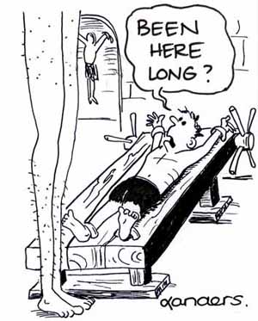
In terms of stretching exercises, there are a few simple rules that you need to remember ...

- Only stretch to the point where there is mild tension - it should never be painful.
- Stretching exercises are static in nature and should be held for the recommended time.
- Do not use any jerky movements when you are stretching - keep them smooth.
- Breathe normally when doing your exercises.

Focus this Week
Like last week, you will be asked to go to the programme for the distance that you wish to train for (i.e. 3km, 5km or 10km). However, no matter which distance you aspire to, the goal for this week is the same - try to increase the amount of time that you spend exercising.

Before we get into the programme itself, there are a few tips for beginner runners that are useful to know at this stage of your training.
Useful Tips for Beginner Runners
The following tips for beginners are taken from the “Time to Run” website ...

 | Run more slowly than you think you should, and be patient - you may be dying to push yourself to the limit, but take it easy and give your body time to adapt to what you’re asking of it. This will help you to avoid injury.
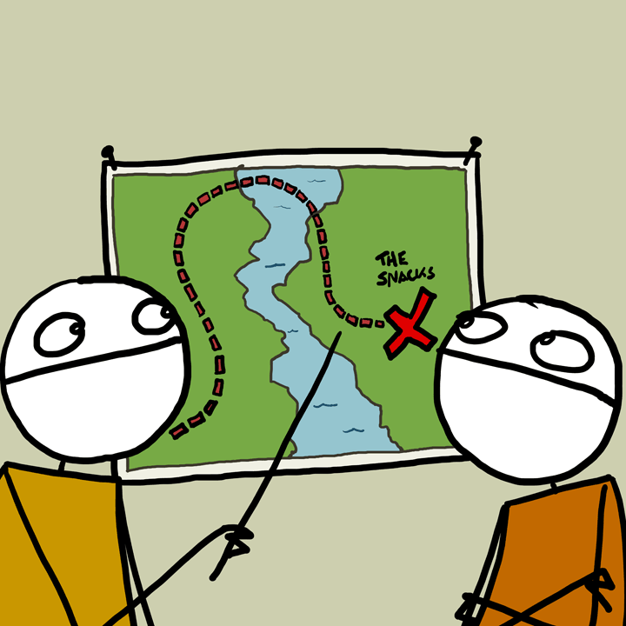 | Don't run as far as you think you should, but run more often than you think you should.
 | Use the "talk test" to figure out if your pace is appropriate. You should be able to talk comfortably while running / walking - slow down if you can’t.
 | Don't be afraid to alternate between running and walking if you need to.
 | Try to get a good running style. Focus upon trying to land on your heels or mid-foot and roll forward towards your toes.
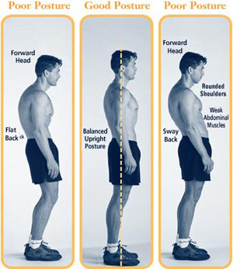 | Develop a good posture. Try to keep your hands at waist level and relax your arms. Keep your head up, back straight and shoulders level. As you get tired it's common to slouch a little bit, and this contributes to shin splints and lower-back pain.
 | Avoid ‘bouncing’ too much. This is wasted energy and can be hard on your feet and legs. Try to land softly on your feet - almost as if running on eggshells.
 | Don’t do exaggerated arm pumping / swinging. Your hands shouldn’t cross your belly button when you’re running / walking.

Go to the Training Programme you wish to Follow
Now that you’re aware of all the top tips for beginners, click on the links below to go to the training programme which is of interest to you ...

3km Walk / Run Training Programme
5km Run Training Programme
10km Run Training Programme



3km Walk / Run Training Programme

Hopefully, last week’s schedule wasn’t too demanding for you. This week will build upon it - but not too much!

Your aim for this week is to go out for three walks lasting between 15 and 20 minutes each. Remember that these should be over-and-above any other walking / exercise that you do as part of your normal daily routine.

Like last week, stay at a fairly easy pace that you are comfortable with. And remember ... if you aren’t free on a particular day, just do it at another time. But try to spread your days out if possible.

The programme you need to follow this week is ...

Date | Activity | Completed
Tuesday 29th June 2010 | 15 minute walk - at an easy pace
Thursday 1st July 2010 | 20 minute walk - at an easy pace
Saturday 3rd July 2010 | 20 minute walk - at an easy pace

Back to Training Programme Menu
5km Run Training Programme

Hopefully, last week’s schedule wasn’t too demanding for you. This week will build upon it - but not too much!

Your aim for this week is to go out walking (not running) on three days, and have ‘rest days’ in between. However, remember to continue any other physical activity that you do as part of your normal daily routine over the whole week!

The programme you need to follow this week is ...

Date | Activity | Completed
Tuesday 29th June 2010 | 20 minute walk - at a moderate pace
Thursday 1st July 2010 | 8 minute walk at a brisk pace followed by  3 minute walk at an easy pace followed by  8 minute walk at a brisk pace followed by  3 minute walk at an easy pace followed by  8 minute walk - at a brisk pace
Saturday 3rd July 2010 | 40 minutes walk - at a moderate pace

If you can’t make a particular day, just do it at another time. But try to spread your days out if possible to allow for ‘rest days’ in between.

Back to Training Programme Menu

10km Run Training Programme

Hopefully, last week’s schedule wasn’t too demanding for you. This week will build upon it - but not too much!

Your aim for this week is to do a mixture of walking and jogging on three days, and have ‘rest days’ in between. However, remember to continue any other physical activity that you do as part of your normal daily routine over the whole week!

The programme you need to follow this week is ...

Date | Activity | Completed
Tuesday 29th June 2010 | 5 minute walk at a brisk pace followed by  15 minute jog at an easy pace followed by  5 minute walk at a brisk pace
Thursday 1st July 2010 | 18 minute jog at an easy pace
Saturday 3rd July 2010 | 5 minute walk at a brisk pace followed by  15 minute jog at an easy pace followed by  5 minute walk at a brisk pace

If you can’t make a particular day, just do it at another time. But try to spread your days out if possible to allow for ‘rest days’ in between.

Back to Training Programme Menu

